Minty Values     Team Inclusivity &  support diversity  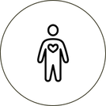   Body neutrality Learn, Research,  Inform  Our RMTs are certified in:  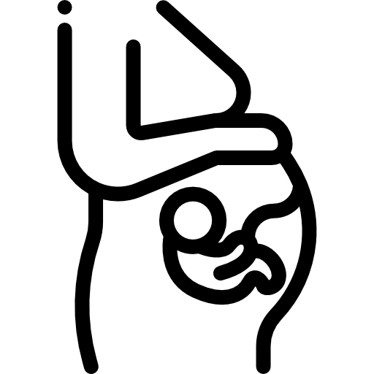 Pre/post-natal  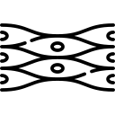 Myofascial  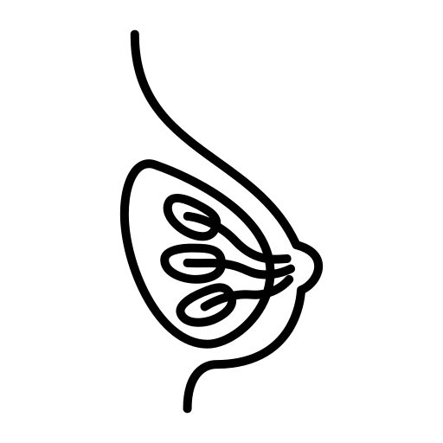 Manual Lymphatic Drainage  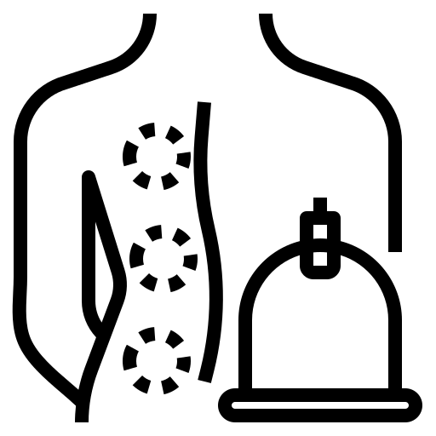 Cupping Therapy  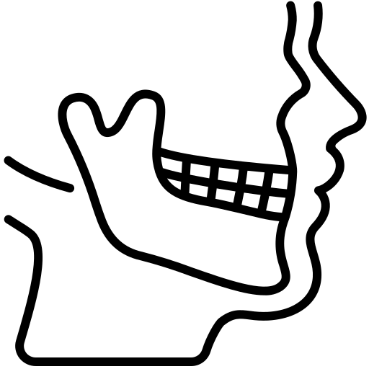 TMJ Massage   Hot Stone Therapy   IASTM  …and more! |  | How to apply  Visit:  www.mintmassage.ca/careers  Click on ‘Book Interview’ to view the appointment calendar and schedule an in-person interview with Jon. |  | 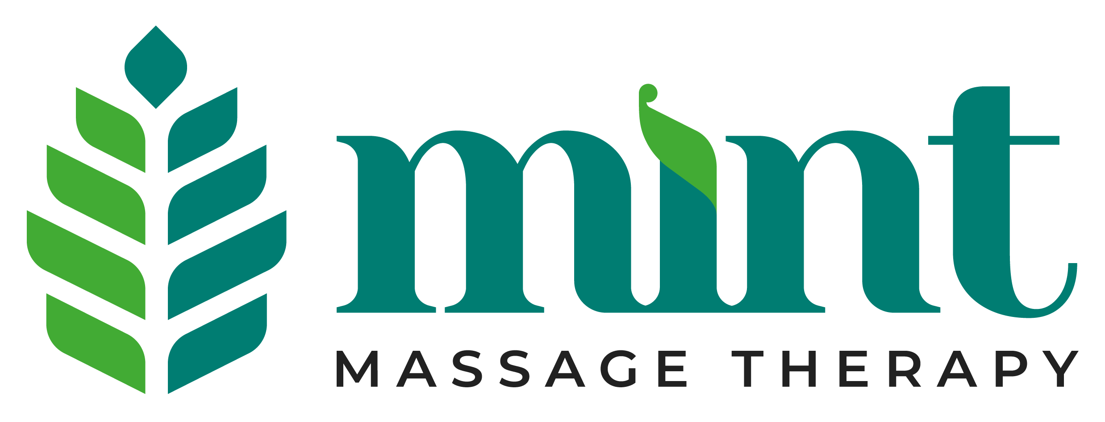  - Hiring Brochure

1 to 3 student practicum placements available at 1252 Pembina Hwy.  Book an interview by visiting:  www.mintmassage.ca/careers |  | Benefits of working for Mint Massage Therapy after Grad  - $1000 bonus when hired as an RMT (terms apply).  - Quarterly 1-on-1s to help you advance in your RMT career.  - Competitive commission with group benefits package starting at $18 bi-weekly.  - Unlimited reasonable vacation time.  - Flexibility in your work schedule.  - New, beautiful space with all new equipment including hydraulic tables, hot towel warmers, table warmers, microfiber linens.  - Ability to increase your massage rates when you want to boost your income. |  | Now Hiring  Mint Massage Therapy is owned by a practicing Massage Therapist. We are currently looking for student practicum placements and to hire new graduates for our Pembina Hwy location.  Our mission is to provide high-quality massage therapy healthcare for all bodies.  We believe in inclusivity and respect, ensuring that every individual who walks through our doors feels seen, heard, and valued.  2026 Important Dates  - February: Staff Holiday Party  - April: Free Workshop on Trauma-informed Care.  - June: Pride Community Event  - September: Truth & Reconciliation Learning Event  

